

Subjective Medical History (see evaluation for objective measures)

Name Age Physician

To ensure you receive a complete and thorough initial evaluation at Mitchell Physical Therapy, please provide us with the important background information on this form. If you do not understand a question, your therapist will assist you. Please note: all content regarding your medical history is kept confidential. Thank you.
Check any condition that applies:
Allergies Diabetes Kidney disease Pregnant
Anemia Dizziness Multiple Sclerosis Rheumatoid
Arthritis Emphysema/Bronchitis Nausea Ringing in ears
Asthma Epilepsy Numbness Stroke
Balance or gait disturbance Headaches Pacemaker Thyroid problems
Blurred vision Heart problems Pain with coughing/sneezing Tuberculosis
Bowel or bladder changes Hepatitis Pain with deep breath Weakness
Cancer High blood pressure Peptic Ulcer  other:
Chemical dependency

PLEASE CIRCLE THE ANSWERS BELOW THAT APPLY.

Do you have a pacemaker: yes no Do you smoke: yes no packs a day

Is there any chance you could be pregnant? yes no

Past Surgery: Spine Knee Shoulder Hip Heart other

What was the date of your injury?
Please tell us how your injury/illness began
Physical Therapy goals: Return to Work Sport Hobby Daily Living

Pain Increases with: Activity Lying down Sitting Standing Driving Medication

Pain Decreases with: Activity Lying down Sitting Standing Driving Medication

Work Status: Light Duty Off Work Normal Schedule Retired Disabled

Please list any medications you are taking:

What prior tests/treatment have you had for this problem?
X-Ray Arthrogram
MRI Physical Therapy
CT Scan Injections
Bone Scan Other (please describe)

Please continue on other side 

Please indicate areas of pain/numbness below

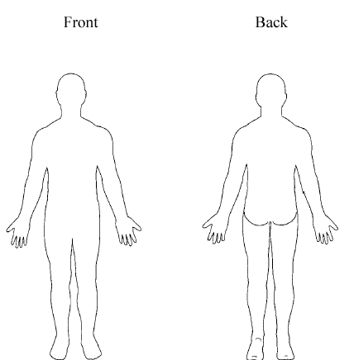

Numbness //// Moderate Pain XX
Severe Pain Shooting Pain

Current pain severity (please circle one):
None 0 1 2 3 4 5 6 7 8 9 10 Worst

Is your current condition:
Getting better Getting worse staying the same?

I understand that all medical information listed above will be kept confidential in accordance with Mitchell Physical Therapy’s Privacy Policy.

All information is true and correct to the best of my knowledge.

Patient Signature Today’s Date

